# INTRODUCTION

## Introduction

The Online Tender Management System (OTMS) is an advanced software platform designed to digitize and streamline the entire tendering process. Traditionally, the process of managing tenders has been paper-intensive, manual, and prone to inefficiencies such as delays, errors, and lack of transparency. OTMS addresses these challenges by providing a centralized, web- based system for creating, submitting, and evaluating tenders in a secure and automated environment. This system is developed using the Java programming language for the application logic and MySQL as the relational database management system (RDBMS) to store and manage tender-related data.

The system benefits both organizations (those issuing tenders) and suppliers (those submitting bids). Registered organizations can create, manage, and publish tender notices, while suppliers can easily access these notices, submit bids electronically, and track the status of their submissions. The OTMS improves the procurement process by reducing paperwork, minimizing human error, ensuring fairness, increasing accessibility, and improving the overall transparency of tender management. By automating key stages such as tender creation, bid submission, evaluation, and awarding contracts, the system contributes to greater efficiency, accuracy, and accountability.

This system is not only beneficial for private sector companies but also serves as a valuable tool for public sector procurement, where transparency and compliance with legal standards are crucial. It demonstrates the potential of leveraging technology to simplify complex procurement procedures and foster better vendor management practices.

## Objectives

The main objectives of the Online Tender Management System (OTMS) are:

* + 1. Digitization of the Tendering Process: To transition from a manual, paper-based process to a fully automated, online system that simplifies and accelerates the tendering process.
    2. Streamlining Tender Creation and Management: To provide organizations with an easy-to-use platform for creating, managing, and publishing tender notices along with all the necessary documentation and specifications.
    3. Facilitation of Electronic Bidding: To allow suppliers to submit their bids electronically, reducing the time and cost associated with physical submissions.
    4. Ensuring Transparency and Fairness: To implement a system that guarantees transparency in the tender evaluation process and ensures that suppliers are evaluated based on predefined, objective criteria.
    5. Secure User Authentication and Access Control: To ensure that only authorized users (organizations and registered suppliers) can access and participate in the system, maintaining the integrity of the tendering process.
    6. Improved Vendor Management: To enable organizations to track supplier submissions, assess bids effectively, and select the most suitable vendor based on clear and transparent evaluation procedures.
    7. Data Integrity and Management: To leverage MySQL as the backend database for secure and efficient management of tender-related data, including user profiles, tender documents, bids, and evaluation results.
    8. Efficiency and Time Reduction: To reduce the time spent on manual tasks and paperwork, ultimately speeding up the tendering cycle and improving operational efficiency.

## Modules

The Online Tender Management System (OTMS) consists of several key modules that work together to provide a complete solution for organizations and suppliers. These modules are designed to manage different aspects of the tendering process:

* + 1. User Authentication and Registration:
       - This module handles user login, registration, and management of user profiles. It ensures secure access to the system and differentiates between different types of users (e.g., organizations, suppliers, and administrators).
       - Features include password management, role-based access control, and multi- level security.
    2. Tender Creation and Management:
       - This module allows organizations to create and manage tenders, including entering detailed project requirements, specifications, deadlines, and uploading necessary documents.
       - It also provides functionality for editing, updating, and publishing tenders online.
    3. Bid Submission:
       - Suppliers can access published tenders, view tender details, and submit their bids electronically through this module. The module ensures that bids are submitted in the correct format and before the specified deadline.
       - It also provides functionality for suppliers to track the status of their submissions, including whether their bids are under evaluation, accepted, or rejected.
    4. Tender Evaluation:
       - This module helps organizations evaluate the received bids based on predefined criteria, such as price, experience, technical specifications, and compliance with tender requirements.
       - It includes features for scoring bids, comparing suppliers, and generating evaluation reports that guide the selection process.
    5. Contract Awarding:
       - After evaluating bids, the system facilitates the process of awarding the contract to the winning supplier.
       - The module generates award letters, sends notifications to suppliers, and updates the system with the contract details.
    6. Notifications and Alerts:
       - This module sends notifications to users at critical stages in the process, such as when a new tender is published, when a bid submission deadline is approaching, or when a bid is evaluated.
       - Both organizations and suppliers receive automated alerts via email or through the system interface to stay informed.
    7. Document Management:
       - This module helps manage all documents related to the tender process, including tender announcements, bid submissions, evaluation reports, and contract agreements.
       - It supports document upload, storage, version control, and easy retrieval.
    8. Reporting and Analytics:
       - Provides real-time reporting and analytics on the status of tenders, bid submissions, evaluations, and contracts.

This module enables administrators and organizations to generate reports for performance analysis, compliance tracking, and decision-making

# SURVEY OF TECHNOLOGIES

## SOFTWARE DESCRIPTION

### ECLIPSE

Eclipse is written mostly in Java and its primary use is for developing Java applications,Eclipse is an integrated development environment (IDE) used in computer programming. It contains a base workspace and an extensible plug-in system for customizing the environment. It is the second most-popular IDE for Java development, and, until 2016, wasthe most popular. Eclipse is written mostly in Java and its primary use is for developing Java applications.

Eclipse Enterprise Edition (EE) is a package for developers who work with Java and web applications. It includes tools for:

* Java
* JavaScript
* TypeScript
* JavaServer Pages and Faces
* Tomcat server
* Apache Maven
* Git

Eclipse EE is a version of Eclipse that comes with tools to make it easier to write server code. For example, you can compile and run a server by pressing the play button.

## LANGUAGES

#### MySQL

MySQL is an open-source relational database management system (RDBMS). A relational

database organizes data into one or more data tables in which data may be related to each other; these relations help structure the data. SQL is a language that programmers use to create, modify and extract data from the relational database, as well as control user access to the database. In addition to relational databases and SQL, an RDBMS like MySQL works with an operating system to implement a relational database in a computer's storage system, manages users, allows for network access and facilitates testing database integrity and creation of backups.

### JAVA

Java is a set of computer software and specifications that provides a software platform for developing application software and deploying it in a cross-platform computing environment. Java is used in a wide variety of computing platforms from embedded devices and mobile phones to enterprise servers and supercomputers. Java applets, which are less common than standalone Java applications, were commonly run in secure, sandboxed environments to provide many features of native applications through being embedded in HTML pages.

### HTML

HTML, or Hypertext Markup Language, is the standard language used to create web pages. It defines the structure and content of web documents using tags and attributes to format text, embed images, create links, and build interactive elements. HTML facilitates communication between web browsers and servers, making it a crucial skill for web developers. HTML was invented by Tim Berners-Lee, a physicist at CERN, in 1990. His goal was to create a simple way to share and access documents over the Internet. Since its inception, HTML has evolved significantly, becoming the foundation of web development. When working with HTML, you use a simple code structure that includes tags and

attributes to build the layout of a webpage.

### CSS

CSS, which stands for Cascading Style Sheets, is a language in web development that enhances the presentation of HTML elements. By applying styles like color, layout, and spacing, CSS makes web pages visually appealing and responsive to various screen sizes. CSS is designed to enable the separation of content and presentation, including layout

### JAVASCRIPT

JavaScript, often abbreviated as JS, is a programming language and core technology of the Web, alongside HTML and CSS. 99% of websites use JavaScript on the client side for webpage behavior. JavaScript is a high-level, often just-in-time compiled language that conforms to the ECMAScript standard.

How the Technologies Work Together:

* + - * Front-End Interaction: The user interacts with the HTML/CSS/JavaScript frontend to browse tenders, submit bids, and view their status. The interface is responsive, ensuring a consistent experience across devices, and JavaScript enhances interactivity (e.g., form validation, real-time updates).
      * Back-End Logic: Once the user submits a form or interacts with the system, the request is sent to the Java-based back-end via Servlets. The back-end processes the request, performs business logic (such as bid evaluation or tender creation), and communicates with the MySQL database to store or retrieve relevant data.
      * Database Communication: The JDBC technology facilitates communication between the Java back-end and the MySQL database. It allows for operations such as retrieving the list of tenders, submitting new bids, and storing evaluation results.

Dynamic Content Rendering: After the business logic is processed, the system uses JSP to render dynamic web pages with the results (e.g., bid status, tender details). The pages are sent back to the user through the browser

# REQUIREMENTS AND ANALYSIS

The Online Tender Management System (OTMS) requires a well-defined set of functional and non-functional specifications, along with hardware and software prerequisites, to ensure the system meets performance, security, and usability goals. This section outlines the requirements, the system architecture, data modeling (ER Diagram), and database normalization, which are key elements in the design and implementation of the system.

## Requirement Specification

The requirement specification defines the essential features and functionalities that the Online Tender Management System (OTMS) must have. These requirements are categorized into functional requirements and non-functional requirements.

#### Functional Requirements:

1. User Authentication & Authorization:
   * The system must provide secure login functionality for users (organizations and suppliers) using credentials such as a username and password.
   * Different user roles (admin, organization, supplier) should have role-based access control (RBAC) to ensure that users can only access the features pertinent to their roles.
2. Tender Creation & Management:
   * Organizations should be able to create and manage tender notices, including uploading documents, specifying tender details (e.g., project scope, deadlines, requirements), and publishing them for suppliers to access.
3. Bid Submission:
   * Suppliers must be able to view tender details and submit their bids electronically, including uploading required documentation (e.g., bid proposals, technical specifications, financial bids).
   * The system must allow suppliers to track the status of their bids (e.g., submitted, under review, accepted, rejected).
4. Bid Evaluation:
   * Organizations should be able to evaluate bids based on predefined criteria such as price, experience, quality, and compliance with tender specifications.
   * The evaluation process should include scoring, comparison of bids, and the ability to generate reports to aid in decision-making.
5. Contract Awarding:
   * Once a bid is evaluated, the system should facilitate awarding the contract to the winning supplier and notify all involved parties.
6. Notification System:
   * The system should send email or in-system notifications to users at various stages (e.g., when a tender is published, when a bid is received, when the contract is awarded).
7. Reporting & Analytics:
   * Administrators and organizations should have access to real-time reporting tools to view tender statistics, supplier performance, and bid trends.

#### Non-Functional Requirements:

1. Performance:
   * The system must handle multiple users simultaneously without performance degradation, ensuring a fast and responsive user experience.
2. Scalability:
   * The system must be able to scale to accommodate more users, tenders, and bids as the system grows over time.
3. Security:
   * Data security must be ensured by implementing secure protocols (e.g., HTTPS), data encryption, and secure user authentication.
   * Only authorized users should have access to sensitive data (e.g., bids, evaluation criteria).
4. Usability:
   * The user interface should be intuitive, with clear navigation and an easy-to-use interface for both organizations and suppliers.
5. Availability:
   * The system should be highly available with minimal downtime, ensuring that users can access the system whenever needed.

## Hardware and Software Requirements

The hardware and software requirements define the technical infrastructure needed to support the Online Tender Management System (OTMS).

#### Hardware Requirements:

1. Server Requirements:
   * Processor: Intel Core i5 or higher (multi-core).
   * RAM: Minimum 8 GB (16 GB recommended for better performance).
   * Storage: 500 GB HDD or SSD (depending on data volume, SSD is preferred for faster access).
   * Network: 100 Mbps internet connection (for cloud-based systems).
   * Backup Server: A secondary server for data backup and disaster recovery (optional for high availability).
2. Client Requirements (for users accessing the system):
   * Processor: Intel Core i3 or higher.
   * RAM: Minimum 4 GB.
   * Storage: 50 GB free space.
   * Network: Stable internet connection (minimum 2 Mbps).
   * Browser: Google Chrome, Mozilla Firefox, or any modern browser with JavaScript support.

#### Software Requirements:

1. Operating System:
   * Server: Linux (Ubuntu, CentOS) or Windows Server.
   * Client: Windows, macOS, or Linux (with a modern web browser).
2. Web Server:
   * Apache Tomcat or Jetty for serving Java-based web applications.
3. Programming Languages:
   * Java (for backend business logic and servlets).
   * JavaScript (for frontend interactivity).
4. Database:
   * MySQL (for storing tender data, bid submissions, evaluation records, etc.).
5. Frameworks & Libraries:
   * Spring Boot (for backend development).
   * Hibernate (optional, for simplifying database interaction).
   * Bootstrap (for responsive frontend design).
   * jQuery or React (optional for advanced UI features).
6. Development Tools:
   * IDE: IntelliJ IDEA or Eclipse (for Java development).
   * Version Control: Git (for code versioning and collaboration).
   * Build Tool: Maven or Gradle (for project dependency management).
7. Security Tools:
   * SSL Certificates (for secure HTTPS communication).
   * OAuth2 or JWT (for secure user authentication).
8. Backup Tools:
   * Backup software or cloud services for scheduled database and file backups.

## Architecture Diagram

The architecture of the Online Tender Management System (OTMS) follows a 3-tier architecture, consisting of Presentation Layer, Business Logic Layer, and Data Access Layer.

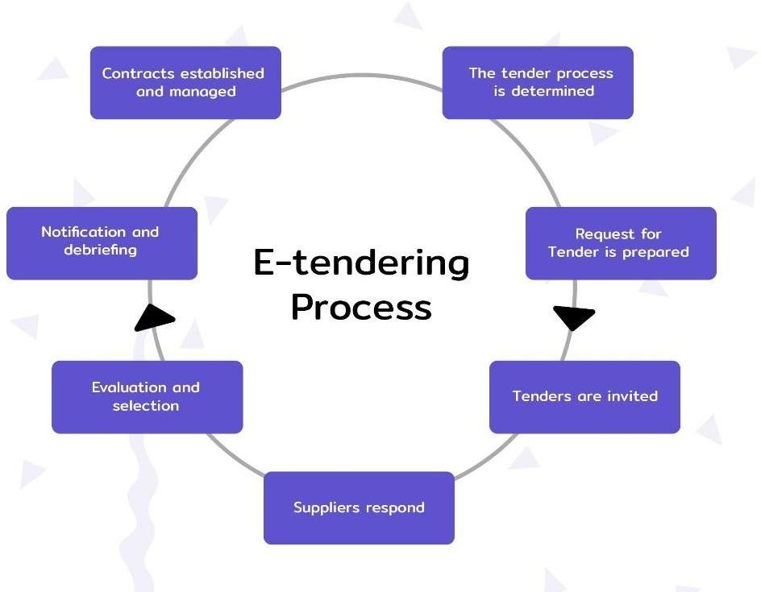

* Frontend: The User Interface (UI) is the layer through which the end-users (organizations and suppliers) interact with the system. It sends requests to the back- end and displays data received from the server.
* Backend: The Application Server processes business logic, validates user inputs, and handles the communication between the UI and the database. It uses Java servlets, JSP, Spring Boot, and JDBC to interact with the MySQL database.
* Database Layer: The MySQL database stores all system data, such as user accounts, tender details, bids, and evaluations.

## ER Diagram

The Entity-Relationship (ER) Diagram represents the data model of the Online Tender Management System (OTMS), showing the key entities, their attributes, and relationships. Below is a simplified version of the ER diagram:

|  |
| --- |
| User |
| user_id(PK) |
| username |
| password |
| role |

Has

|  |
| --- |
| Tender |
| tender_id(PK) |
| title |
| description |
| start_date |
| end_date |
| documents |

|  |
| --- |
| Bid |
| bid_id |
| supplier_id |
| Tender_id |
| Bid_amount |
| Bid_status |

 Has  submitted by

|  |
| --- |
| Evaluation |
| eval_id |
| tender_id |
| score |
| comments |

|  |
| --- |
| Contract |
| Contract_id(PK) |
| Bid_id(FK) |
| Contract_terms |

* User: Represents the users of the system (organization, supplier, and admin).
* Tender: Represents the tender notices created by organizations.
* Bid: Represents the bids submitted by suppliers in response to a tender.
* Evaluation: Represents the evaluation results for each bid.
* Contract: Represents the contract awarded to the winning supplier.

# PROGRAM CODE

## Admin Home

<%@ page language="java" contentType="text/html; charset=ISO-8859-1" pageEncoding="ISO-8859-1"%>

<%@page import="java.sql.*, com.hit.utility.DBUtil, javax.servlet.annotation.WebServlet" errorPage="errorpage.jsp"%>

<!DOCTYPE html PUBLIC "-//W3C//DTD HTML 4.01 Transitional//EN" ["http://www.w3.org/TR](http://www.w3.org/TR/html4/loose.dtd)/[html4/loose.dtd">](http://www.w3.org/TR/html4/loose.dtd)

<html lang="en">

<head>

<link rel="shortcut icon" type="image/png" href="images/Banner_Hit.png">

<!--link rel="shortcut icon" type="image/ico" href="images/hit_fevicon.ico"-->

<meta charset="utf-8">

<meta http-equiv="X-UA-Compatible" content="IE=edge">

<meta name="viewport" content="width=device-width, initial-scale=1.0">

<title>Tender Management System</title>

<link rel="stylesheet" href="css/bootstrap.min.css">

<link rel="stylesheet" href="css/annimate.css">

<link href="css/font-awesome.min.css" type="text/css" rel="stylesheet">

<link href="css/SpryTabbedPanels.css" type="text/css" rel="stylesheet">

<!--link rel="stylesheet" href="css/styles.css"-->

<link href="https://fonts.googleapis.com/css?family=Black+Ops+One" rel="stylesheet">

<link href="css/bootstrap-dropdownhover.min.css">

<link rel="stylesheet" href="css/style2.css">

</head>

<body>

<%

String user = (String)session.getAttribute("user");

String uname = (String)session.getAttribute("username"); String pword = (String)session.getAttribute("password");

if(!user.equalsIgnoreCase("admin") || uname.equals("") || pword.equals("")){ response.sendRedirect("loginFailed.jsp");

}

%>

<!-- Including the header of the page -->

<jsp:include page="header.jsp"></jsp:include>

<jsp:include page="adminMenu.jsp"></jsp:include>

<div class="clearfix hidden-sm hidden-xs" style="color:white;background-color: green; margin-top:-15px; margin-bottom: 12px"><marquee>Welcome to Tender Management Site</marquee>

</div> <!--A green color line between header and body part-->

<div class="container-fluid">

<div class="notice">

<div class="col-md-3"style="margin-left:2%">

<% Connection con = DBUtil.provideConnection(); %>

<jsp:include page="notice.jsp"></jsp:include><br>

<!-- Next marquee starting-->

<jsp:include page="approved.jsp"></jsp:include><br>

</div> <!-- End of col-md-3-->

</div> <!-- End of notice class-->

<div class="col-md-8">

<div class="marquee" style="border:2px black hidden; background-color:white">

<h4 style="background-color:black; margin-top:-1.8px; margin-bottom:1px;padding: 5px; text-align: center;color:red;font-weight:bold">

&nbsp; <span id="pagetitle">Admin Account</span></h4>

<div class="marquee-content" style="align:center; padding-top:200px;min- height:750px;background-color:cyan">

<h1><center>Hey Admin! Welcome to Our Tender Management system</center></h1>

<h2><center>Here You can manage your vendors, add tenders and assign it to vendors according to their high bids</center></h2>

<h3><center>Go on the about menu section links to explore the site</center></h3>

<h3><center>You can also add notice,update it and delete the notice board from the database!</center></h3>

</div>

</div>

</div>

<a><h1></h1></a>

</div>

<!-- Now from here the footer section starts-->

<!-- Including the footer of the page -->

<jsp:include page="footer.jsp"></jsp:include>

</body>

</html>

## Admin Menu

<%@ page language="java" contentType="text/html; charset=ISO-8859-1" pageEncoding="ISO-8859-1"%>

<!DOCTYPE html PUBLIC "-//W3C//DTD HTML 4.01 Transitional//EN" ["http://www.w3.org/TR](http://www.w3.org/TR/html4/loose.dtd)/[html4/loose.dtd">](http://www.w3.org/TR/html4/loose.dtd)

<html>

<head>

<meta http-equiv="Content-Type" content="text/html; charset=ISO-8859-1">

<title>Admin Home</title>

</head>

<body>

<div class="menubar secondnav " style="background-color:white;">

<div id="menucontent" class="container secondnav">

<div id="collapsable-nav" class="collapse navbar-collapse hidden-lg hidden-md">

<ul id="nav-list" class="nav navbar-nav navbar-left pull-left">

<li id="navHomeButton">

<a href="adminHome.jsp">

<span class="glyphicon glyphicon-home"></span> Home</a> <!--Home button is here -->

</li>

<a class="dropdown-toggle " data-toggle="dropdown" data-animations="fadeIn fadeInLeft fadeInUp fadeInRight" data-hover="dropdown">Vendors

<span class="caret"></span></a> Dropdown under about us category

<ul class="dropdown-menu">

<li><a href="viewVendor.jsp">View All Vendors</a></li>

<li><a href="ApproveVendor">Approve Vendors</a></li>

<li><a href="vendorDetail.jsp">Vendor Detail</a></li>

</ul>

</li> -->

<li><a href="adminViewVendor.jsp">Vendors</a></li>

<li class="dropdown">

<a class="dropdown-toggle" data-toggle="dropdown" data-hover="dropdown" data-animations="fadeIn fadeInLeft fadeInUp fadeInRight">

<!--Dropdown under tender category -->

<span class="caret"></span></a>

<ul class="dropdown-menu">

<li><a href="viewTender.jsp">View all Tenders</a></li>

<li><a href="createTender.jsp">Create New Tender</a></li>

<li><a href="viewTenderBids.jsp">View Tender Bids</a></li>

<li><a href="viewTenderBids.jsp">Accept a bid</a></li>

<li><a href="viewAssignedTenders.jsp">View Assigned Tenders</a></li>

</ul>

</li>

<li class="dropdown">

<a class="dropdown-toggle " data-toggle="dropdown" data-animations="fadeIn fadeInLeft fadeInUp fadeInRight" data-hover="dropdown">Notice

<span class="caret"></span></a> <!--Dropdown under about us category -->

<ul class="dropdown-menu">

<li><a href="addNotice.jsp">Add Notice</a></li>

<li><a href="removeNotice.jsp">Remove Notice</a></li>

<li><a href="updateNotice.jsp">Update Notice</a></li>

<li><a href="viewNotice.jsp">View All Notice</a></li>

</ul>

</li>

<li>

<a href="LogoutSrv">Logout</a>

</li>

<li>

<!-- Form for searching any tenders or items-->

<form class="navbar-form hidden-xs" action="searchTender.jsp" >

<div class="form-group" >

<input type="text" name="tid" class="form-control" placeholder="Find Tenders by name or tenderId" style="margin-left:10px;" required>

</div>

<button type="submit" class="btn btn-primary" >Search</button>

</form>

<!--End of form section-->

</li>

</ul>

</div>

</div>

</div>

</body>

</html><%@ page language="java" contentType="text/html; charset=ISO-8859-1" pageEncoding="ISO-8859-1"%>

## Tendor Details

<%@page import="java.sql.*,

com.hit.utility.DBUtil,com.hit.dao.VendorDao,com.hit.dao.VendorDaoImpl,com.hit.beans.V endorBean, javax.servlet.annotation.WebServlet" errorPage="errorpage.jsp"%>

<!DOCTYPE html PUBLIC "-//W3C//DTD HTML 4.01 Transitional//EN" ["http://www.w3.org/TR](http://www.w3.org/TR/html4/loose.dtd)/[html4/loose.dtd"](http://www.w3.org/TR/html4/loose.dtd)>

<html lang="en">

<head>

<link rel="shortcut icon" type="image/png" href="images/Banner_Hit.png">

<!--link rel="shortcut icon" type="image/ico" href="images/hit_fevicon.ico"-->

<meta charset="utf-8">

<meta http-equiv="X-UA-Compatible" content="IE=edge">

<meta name="viewport" content="width=device-width, initial-scale=1.0">

<title>Tender Management System</title>

<link rel="stylesheet" href="css/bootstrap.min.css">

<link rel="stylesheet" href="css/annimate.css">

<link href="css/font-awesome.min.css" type="text/css" rel="stylesheet">

<link href="css/SpryTabbedPanels.css" type="text/css" rel="stylesheet">

<!--link rel="stylesheet" href="css/styles.css"-->

<link href="https://fonts.googleapis.com/css?family=Black+Ops+One" rel="stylesheet">

<link href="css/bootstrap-dropdownhover.min.css">

<link rel="stylesheet" href="css/style2.css">

</head>

<body>

<%

String user = (String)session.getAttribute("user");

String uname = (String)session.getAttribute("username"); String pword = (String)session.getAttribute("password");

if(!user.equalsIgnoreCase("admin") || uname.equals("") || pword.equals("")){ response.sendRedirect("loginFailed.jsp"); }

%>

<!-- Including the header of the page -->

<jsp:include page="header.jsp"></jsp:include>

<jsp:include page="adminMenu.jsp"></jsp:include>

<div class="clearfix hidden-sm hidden-xs" style="color:white;background-color: green; margin-top:-15px; margin-bottom: 12px"><marquee>Welcome to Tender Management Site</marquee>

</div> <!--A green color line between header and body part-->

<div class="container-fluid">

<div class="notice">

<div class="col-md-3"style="margin-left:2%">

<% Connection con = DBUtil.provideConnection(); %>

<jsp:include page="notice.jsp"></jsp:include><br>

<jsp:include page="approved.jsp"></jsp:include><br>

</div> <!-- End of col-md-3-->

</div> <!-- End of notice class-->

<%-- <jsp:include page="login.jsp"></jsp:include> --%>

<div class="col-md-8">

<!-- <div class="marquee" style="border:2px black hidden; background- color:white">

<h4 style="background-color:black; margin-top:-1.8px; margin-bottom:1px;padding: 5px; text-align: center;color:red;font-weight:bold">

&nbsp; <span id="pagetitle">Tender Creation</span></h4>pagetitle id is given here

<div class="marquee-content" style="align:center; padding-top:5px;min- height:750px;background-color:cyan">-->

<table style="border-radius:10px" >

<tr >

<td id="show" style="min-width:632px;min-height:0px;color:blue">Vendor Details For Vendor Id : <%= request.getParameter("vid") %></td>

</tr>

</table>

<%

String vendorId = request.getParameter("vid"); VendorDao dao = new VendorDaoImpl();

VendorBean vendor = dao.getVendorDataById(vendorId);

%>

<table style="background-color:white;margin-left:35%">

<th colspan="2">Vendor Contact Details</th>

<tr><td> Vendor Name : </td><td><%=vendor.getName()

%></td></tr>

<tr><td> Mobile No : </td><td><%=vendor.getMobile() %></td></tr>

<tr><td>Email Id :</td><td><%=vendor.getEmail() %></td></tr>

<tr><td> Company Name :</td><td><%=vendor.getCompany()

%></td></tr>

<tr><td> Address : </td><td><%=vendor.getAddress() %></td></tr>

</table>

<!-- </div>

</div> -->

</div>

</div> <!-- End of container-fluid-->

<jsp:include page="footer.jsp"></jsp:include>

</body>

<style>

input,textarea,select{ min-width:450px; font-size:16px;

background-color:#f8f8f8;

}

input:hover,textarea:hover,select:hover{ min-width:450px;

background-color:white;

}

table, th, td {

margin-bottom:10px; margin-left:20%; font-size:20px;

border: 2px solid green; text-align:center; background-color:white; color:#003399;

}

td {

padding: 12px; background-color:none;

}

th{

padding:12px;

background-color:#660033; color:white;

font-weight:bold;

}

</style>

</html>

## TenderForm

<%@ page language="java" contentType="text/html; charset=ISO-8859-1" pageEncoding="ISO-8859-1"%>

<%@page import="java.sql.*,com.hit.dao.VendorDao,com.hit.dao.VendorDaoImpl, java.util.Date,com.hit.beans.TenderBean,com.hit.dao.TenderDao,com.hit.dao.TenderDaoImp l, com.hit.utility.DBUtil, javax.servlet.annotation.WebServlet, com.hit.beans.VendorBean" errorPage="errorpage.jsp"%>

<!DOCTYPE html PUBLIC "-//W3C//DTD HTML 4.01 Transitional//EN" ["http://www.w3.org/TR](http://www.w3.org/TR/html4/loose.dtd)/[html4/loose.dtd">](http://www.w3.org/TR/html4/loose.dtd)

<html lang="en">

<head>

<link rel="shortcut icon" type="image/png" href="images/Banner_Hit.png">

<!--link rel="shortcut icon" type="image/ico" href="images/hit_fevicon.ico"-->

<meta charset="utf-8">

<meta http-equiv="X-UA-Compatible" content="IE=edge">

<meta name="viewport" content="width=device-width, initial-scale=1.0">

<title>Tender Management System</title>

<link rel="stylesheet" href="css/bootstrap.min.css">

<link rel="stylesheet" href="css/annimate.css">

<link href="css/font-awesome.min.css" type="text/css" rel="stylesheet">

<link href="css/SpryTabbedPanels.css" type="text/css" rel="stylesheet">

<!--link rel="stylesheet" href="css/styles.css"-->

<link href="https://fonts.googleapis.com/css?family=Black+Ops+One" rel="stylesheet">

<link href="css/bootstrap-dropdownhover.min.css">

<link rel="stylesheet" href="css/style2.css">

</head>

<body>

<%

String user = (String)session.getAttribute("user");

String uname = (String)session.getAttribute("username"); String pword = (String)session.getAttribute("password");

if(user== null || !user.equalsIgnoreCase("user") || uname.equals("") ||

pword.equals("")){

response.sendRedirect("loginFailed.jsp");}

%>

<jsp:include page="header.jsp"></jsp:include>

<jsp:include page="vendorMenu.jsp"></jsp:include>

<div class="clearfix hidden-sm hidden-xs" style="color:white;background-color: green; margin-top:-15px; margin-bottom: 12px"><marquee>Welcome to Tender Management Site</marquee>

</div> <!--A green color line between header and body part--

<div class="container-fluid">

<div class="notice">

<div class="col-md-3"style="margin-left:2%">

<% Connection con = DBUtil.provideConnection(); %>

<jsp:include page="notice.jsp"></jsp:include><br>

<!-- Next marquee starting-->

<jsp:include page="approved.jsp"></jsp:include><br>

</div>

</div>

<%-- <jsp:include page="login.jsp"></jsp:include> --%>

<div class="col-md-8">

<h4 style="background-color:black; margin-top:-1.8px; margin-bottom:1px;padding: 5px; text-align: center;color:red;font-weight:bold">

&nbsp; <span id="pagetitle">Tender Creation</span></h4>pagetitle id is given here

<div class="marquee-content" style="align:center; padding-top:5px;min-

height:750px;background-color:cyan">

-->

<table style="border-radius:10px" >

<tr >

<td id="show" style="min-width:632px;min-height:0px;color:blue">Enter Bid Amount And Deadline To Bid</td>

</tr>

</table>

<%

String vendorId = request.getParameter("vid"); String tenderId = request.getParameter("tid"); TenderDao dao = new TenderDaoImpl(); VendorDao daov = new VendorDaoImpl();

TenderBean tender = dao.getTenderDataById(tenderId); VendorBean vendor = daov.getVendorDataById(vendorId);

%>

<form action="BidTenderSrv" method="post">

<table style="background-color:white">

<th colspan="2">Bid For The Tendor<input type="hidden" name="vid" value="<%= vendorId%>"></th>

<tr><td style="color:red"> Tendor Id : </td><td><input type="hidden" name="tid" value="<%= tender.getId()%>"><%= tender.getId()%></td></tr>

<tr><td style="color:red"> Tendor Name: </td><td><%= tender.getName()%></td></tr>

<tr><td style="color:red"> Tender Type:</td><td> <%= tender.getType()%></td></tr>

<tr><td style="color:red"> Deadline Reqd:</td><td><% tender.getDeadline()%></td></tr>

<tr><td style="color:red"> Base Price :</td><td> <%= tender.getPrice()%></td></tr>

<tr><td style="color:red"> Location :</td><td> <%= tender.getLocation()%></td><

<tr><td style="color:red"> Description: </td><td><textarea rows="2" cols="40" readonly><%=tender.getDesc() %> </textarea></td></tr>

<tr><td style="color:red"> Bid Amount : </td><td> <input type="number" name="bidamount" required="required" min="<%= tender.getPrice()%>" value="<%=tender.getPrice()%>"></td></tr>

<input type="hidden" name="biddeadline" required="required" value="<%= tender.getDeadline()%>">

<tr><td colspan="2" align="center" value="Launch"><input type="submit" value="Bid Now" style="background-color:green;color:white;"></td></tr>

</table>

</form>

</div> <!-- End of container-fluid-->

<!-- <div class="container" style="height:300px">

ucomment this if you want to add some space in the lower part of page

</div> -->

<!-- Now from here the footer section starts-->

<!-- Including the footer of the page -->

<jsp:include page="footer.jsp"></jsp:include>

</body>

<style>

input,textarea,select{ min-width:450px; font-size:16px;

background-color:#f8f8f8;

}

input:hover,textarea:hover,select:hover{ min-width:450px;

background-color:white;

}

table, th, td {

margin-bottom:10px; margin-left:20%; font-size:20px;

border: 2px solid green; text-align:center; background-color:white; color:#003399;

}

td {

padding: 12px; background-color:none;

}

th{

padding:12px;

background-color:#660033; color:white;

font-weight:bold;

}

</style>

</html>

## Login

<%@ page language="java" contentType="text/html; charset=ISO-8859-1" pageEncoding="ISO-8859-1"%>

<%@page import="java.sql.*, com.hit.utility.DBUtil, javax.servlet.annotation.WebServlet" errorPage="errorpage.jsp"%>

<!DOCTYPE html PUBLIC "-//W3C//DTD HTML 4.01 Transitional//EN" ["http://www.w3.org/TR](http://www.w3.org/TR/html4/loose.dtd)/[html4/loose.dtd">](http://www.w3.org/TR/html4/loose.dtd)

<html lang="en">

<head>

<link rel="shortcut icon" type="image/png" href="images/Banner_Hit.png">

<!--link rel="shortcut icon" type="image/ico" href="images/hit_fevicon.ico"-->

<meta charset="utf-8">

<meta http-equiv="X-UA-Compatible" content="IE=edge">

<meta name="viewport" content="width=device-width, initial-scale=1.0">

<title>Tender Management System</title>

<link rel="stylesheet" href="css/bootstrap.min.css">

<link rel="stylesheet" href="css/annimate.css">

<link href="css/font-awesome.min.css" type="text/css" rel="stylesheet">

<link href="css/SpryTabbedPanels.css" type="text/css" rel="stylesheet">

<!--link rel="stylesheet" href="css/styles.css"-->

<link href="https://fonts.googleapis.com/css?family=Black+Ops+One" rel="stylesheet">

<link href="css/bootstrap-dropdownhover.min.css">

<link rel="stylesheet" href="css/style2.css">

<style>

.tab{

border-radius:1px; border:1px black solid;

background-color: #FFE5CC; margin-left: 25%; width:450px;

color:green;

font-weight: bold; font-style:normal; text-align:center; font-size: 20px;

margin-bottom:10px; padding:20px;

}

</style>

</head>

<body>

<!-- Including the header of the page -->

<jsp:include page="loginHeader.jsp"></jsp:include>

<jsp:include page="menu.jsp"></jsp:include>

<div class="clearfix hidden-sm hidden-xs" style="color:white;background-color: green; margin-top:-15px; margin-bottom: 12px"><marquee>Welcome to Tender Management Site</marquee>

</div> <!--A green color line between header and body part-->

<div class="container-fluid">

<div class="notice">

<div class="col-md-3"style="margin-left:2%">

<% Connection con = DBUtil.provideConnection(); %> jsp:include page="notice.jsp"></jsp:include><br>

<!-- Next marquee starting-->

<jsp:include page="approved.jsp"></jsp:include><br>

</div> <!-- End of col-md-3-->

</div> <!-- End of notice class-->

<%-- <jsp:include page="login.jsp"></jsp:include> --%>

<div class="col-md-8">

<div class="marquee" style="border:2px black hidden; background-color:white; padding-top:0px;">

<h4 style="background-color:black; margin-top:-1.8px; margin-bottom:1px;padding: 5px; text-align: center;color:red;font-weight:bold">

&nbsp; <span id="pagetitle">Account Login</span></h4><!-- pagetitle id is given here -->

<div class="marquee-content" style="align:center; padding-top:100px;min- height:750px;background-color:cyan">

<table class="tab" style="color:blue;margin-bottom:50px;background-color:white; padding:25px;">

<tr>

<td id="show"></td>

</tr>

</table>

<table class="tab hd brown">

<tr>

<td style="color:brown">USER LOGIN</td>

</tr>

</table>

<table class="tab hd blue" border="0px" cellpadding="10" cellspacing="10">

<tr>

<td><form action="LoginSrv" method="post">

<br>Username: &nbsp; <input type="text" placeholder="Enter Email or VendorId" name="username" required="required" style="color:black;font- size:19px;"><br/><br/>

Password: &nbsp; <input type="password" name="password" required="required" style="color:black;font-size:19px;"><br/><br/>

<input type="submit" value="Login As Vendor" name="user">&nbsp; &nbsp; &nbsp; &nbsp;

<input type="submit" value="Login As Admin" name="user"><br/><br/>

</form>

</td>

</tr>

</table>

</div>

</div>

</div>

</div> <!-- End of container-fluid-->

<!-- <div class="container" style="height:300px">

ucomment this if you want to add some space in the lower part of page

</div> -->

<!-- Now from here the footer section starts-->

<!-- Including the footer of the page -->

<jsp:include page="footer.jsp"></jsp:include>

</body>

</html> Register

<%@ page language="java" contentType="text/html; charset=ISO-8859-1" pageEncoding="ISO-8859-1"%>

<%@page import="java.sql.*, com.hit.utility.DBUtil, javax.servlet.annotation.WebServlet" errorPage="errorpage.jsp"%>

<!DOCTYPE html PUBLIC "-//W3C//DTD HTML 4.01 Transitional//EN" ["http://www.w3.org/TR](http://www.w3.org/TR/html4/loose.dtd)/[html4/loose.dtd">](http://www.w3.org/TR/html4/loose.dtd)

<html lang="en">

<head>

<link rel="shortcut icon" type="image/png" href="images/Banner_Hit.png">

<!--link rel="shortcut icon" type="image/ico" href="images/hit_fevicon.ico"-->

<meta charset="utf-8">

<meta http-equiv="X-UA-Compatible" content="IE=edge">

<meta name="viewport" content="width=device-width, initial-scale=1.0">

<title>Tender Management System</title>

<link rel="stylesheet" href="css/bootstrap.min.css">

<link rel="stylesheet" href="css/annimate.css">

<link href="css/font-awesome.min.css" type="text/css" rel="stylesheet">

<link href="css/SpryTabbedPanels.css" type="text/css" rel="stylesheet">

<!--link rel="stylesheet" href="css/styles.css"-->

<link href="https://fonts.googleapis.com/css?family=Black+Ops+One" rel="stylesheet">

<link href="css/bootstrap-dropdownhover.min.css">

<link rel="stylesheet" href="css/style2.css">

<style>

.tab{

border-radius:10px;

border:1px black solid; background-color: #FFE5CC; margin-left: 25%; width:450px;

color:green;

font-weight: bold; font-style:normal; text-align:center; font-size: 20px; margin-bottom:10px; padding:20px;

}

</style>

</head>

<body>

<!-- Including the header of the page -->

<jsp:include page="loginHeader.jsp"></jsp:include>

<jsp:include page="menu.jsp"></jsp:include>

<div class="clearfix hidden-sm hidden-xs" style="color:white;background-color: green; margin-top:-15px; margin-bottom: 12px"><marquee>Welcome to Tender

Management Site</marquee>

</div>

<div class="container-fluid">

<div class="notice">

<div class="col-md-3"style="margin-left:2%">

<% Connection con = DBUtil.provideConnection(); %>

<jsp:include page="notice.jsp"></jsp:include><br>

<jsp:include page="approved.jsp"></jsp:include><br>

</div>

</div>

<%-- <jsp:include page="login.jsp"></jsp:include> --%>

<div class="col-md-8">

<div class="marquee" style="border:2px black hidden; background-color:white">

<h4 style="background-color:black; margin-top:-1.8px; margin-tom:1px;padding: 5px; text-align: center;color:red;font-weight:bold">

&nbsp; <span id="pagetitle">Vendor Registration</span></h4><!-- pagetitle id is given here -->

<div class="marquee-content" style="align:center; padding-top:5px;min- height:750px;background-color:cyan">

<table class="tab hd " style="color:blue;margin-bottom:50px;background- color:white; ">

<tr>

<td id="show"></td>

</tr>

</table>

<table class="tab hd brown">

<tr>

<td style="color:brown">Register New Vendor</td>

</tr>

</table>

<table class="tab hd blue" border="0px" cellpadding="10" cellspacing="10">

<tr>

<td>

<form action="RegisterSrv" method="post">

<br>

Vendor Name: <input type="text" name="vname" required="required"><br/><br/> Email Id &nbsp; &nbsp; &nbsp; : <input type="email" name="vemail" required="required"><br/><br/>

Mobile No.&nbsp; &nbsp; : <input type="phone" name="vmob" required="required"><br/><br/>

Address: &nbsp; &nbsp;&nbsp;&nbsp; &nbsp;<input type="text" name="vaddr" required="required"><br/><br/>

Company &nbsp; &nbsp;&nbsp; : <input type="text" name="cname" required="required"><br/><br/>

Password: &nbsp; &nbsp;&nbsp; <input type="password" name="vpass" required="required"><br/><br/>

<input type="submit" value="Register" name="user">

</form>

</td>

</tr>

</table>

</div>

</div>

</div>

</div> <!-- End of container-fluid-->

<!-- Now from here the footer section starts-->

<!-- Including the footer of the page -->

<jsp:include page="footer.jsp"></jsp:include>

</body>

</html>

## Vendor Home

<%@ page language="java" contentType="text/html; charset=ISO-8859-1" pageEncoding="ISO-8859-1"%>

<%@page import="java.sql.*, com.hit.utility.DBUtil, javax.servlet.annotation.WebServlet" errorPage="errorpage.jsp"%>

<!DOCTYPE html PUBLIC "-//W3C//DTD HTML 4.01 Transitional//EN" ["http://www.w3.org/TR](http://www.w3.org/TR/html4/loose.dtd)/[html4/loose.dtd">](http://www.w3.org/TR/html4/loose.dtd)

<html lang="en">

<head>

<link rel="shortcut icon" type="image/png" href="images/Banner_Hit.png">

<!--link rel="shortcut icon" type="image/ico" href="images/hit_fevicon.ico"-->

<meta charset="utf-8">

<meta http-equiv="X-UA-Compatible" content="IE=edge">

<meta name="viewport" content="width=device-width, initial-scale=1.0">

<title>Tender Management System</title>

<link rel="stylesheet" href="css/bootstrap.min.css">

<link rel="stylesheet" href="css/annimate.css">

<link href="css/font-awesome.min.css" type="text/css" rel="stylesheet">

<link href="css/SpryTabbedPanels.css" type="text/css" rel="stylesheet">

<!--link rel="stylesheet" href="css/styles.css"-->

<link href="https://fonts.googleapis.com/css?family=Black+Ops+One" rel="stylesheet">

<link href="css/bootstrap-dropdownhover.min.css">

<link rel="stylesheet" href="css/style2.css">

</head>

<body>

<%

String user = (String)session.getAttribute("user");

String uname = (String)session.getAttribute("username"); String pword = (String)session.getAttribute("password");

if(!user.equalsIgnoreCase("user") || uname.equals("") || pword.equals("")){

response.sendRedirect("loginFailed.jsp");

}

%>

<jsp:include page="header.jsp"></jsp:include>

<jsp:include page="vendorMenu.jsp"></jsp:include>

<div class="clearfix hidden-sm hidden-xs" style="color:white;background-color: green; margin-top:-15px; margin-bottom: 12px"><marquee>Welcome to Tender Management Site</marquee>

</div>

<div class="container-fluid">

<div class="notice">

<div class="col-md-3"style="margin-left:2%">

<% Connection con = DBUtil.provideConnection(); %>

<jsp:include page="notice.jsp"></jsp:include><br>

<jsp:include page="approved.jsp"></jsp:include><br>

</div>

</div>

<div class="col-md-8">

<div class="marquee" style="border:2px black hidden; background-color:white">

<h4 style="background-color:black; margin-top:-1.8px; margin-bottom:1px;padding: 5px; text-align: center;color:red;font-weight:bold">

&nbsp; <span id="pagetitle">VENDOR ACCOUNT</span></h4><!-- pagetitle id is

given here -->

<div class="marquee-content" style="align:center; padding- top:200px;miheight:750px;background-color:cyan">

<h1><center>Hey Dude! Welcome to Our Tender Management system</center></h1>

<h><center>Here You can manage your tenders,view tenders and bid for tenders according to their deadline and base price</center></h2>

<h3><center>Go on the about menu section links to explore the site</center></h3>

<h3><center>You can also update your profile, change password and can explore many more things!</center></h3>

</div>

</div>

</div>

<a><h1></h1></a>

</div>

<!-- <div class="container" style="height:300px">

ucomment this if you want to add some space in the lower part of page

</div> -->

<jsp:include page="footer.jsp"></jsp:include>

</body>

</html>

### VIEW PROFILE

<%@ page language="java" contentType="text/html; charset=ISO-8859-1" pageEncoding="ISO-8859-1"%>

<%@page import="java.sql.*, com.hit.utility.DBUtil, javax.servlet.annotation.WebServlet, com.hit.beans.VendorBean" errorPage="errorpage.jsp"%>

<!DOCTYPE html PUBLIC "-//W3C//DTD HTML 4.01 Transitional//EN" ["http://www.w3.org/TR](http://www.w3.org/TR/html4/loose.dtd)/[html4/loose.dtd">](http://www.w3.org/TR/html4/loose.dtd)

<html lang="en">

<head>

<link rel="shortcut icon" type="image/png" href="images/Banner_Hit.png">

<!--link rel="shortcut icon" type="image/ico" href="images/hit_fevicon.ico"-->

<meta charset="utf-8">

<meta http-equiv="X-UA-Compatible" content="IE=edge">

<meta name="viewport" content="width=device-width, initial-scale=1.0">

<title>Tender Management System</title>

<link rel="stylesheet" href="css/bootstrap.min.css">

<link rel="stylesheet" href="css/annimate.css">

<link href="css/font-awesome.min.css" type="text/css" rel="stylesheet">

<link href="css/SpryTabbedPanels.css" type="text/css" rel="stylesheet">

<!--link rel="stylesheet" href="css/styles.css"-->

<link href="https://fonts.googleapis.com/css?family=Black+Ops+One" rel="stylesheet">

<link href="css/bootstrap-dropdownhover.min.css">

<link rel="stylesheet" href="css/style2.css">

</head>

<body>

<%

String user = (String)session.getAttribute("user");

String uname = (String)session.getAttribute("username"); String pword = (String)session.getAttribute("password");

if(!user.equalsIgnoreCase("user") || uname.equals("") || pword.equals("")){ response.sendRedirect("loginFailed.jsp");

}

%>

<jsp:include page="header.jsp"></jsp:include>

<jsp:include page="vendorMenu.jsp"></jsp:include>

<div class="clearfix hidden-sm hidden-xs" style="color:white;background-color: green; margin-top:-15px; margin-bottom: 12px"><marquee>Welcome to Tender Management Site</marquee>

</div> <!--A green color line between header and body part-->

<div class="container-fluid">

<div class="notice">

<div class="col-md-3"style="margin-left:2%">

<% Connection con = DBUtil.provideConnection(); %>

<jsp:include page="notice.jsp"></jsp:include><br>

<jsp:include page="approved.jsp"></jsp:include><br>

</div> <!-- End of col-md-3-->

</div> <!-- End of notice class-->

<!-- Next part of same container-fluid in which galary or other information will be shown-->

<%-- <jsp:include page="login.jsp"></jsp:include> --%>

<div class="col-md-8">

<!-- <div class="marquee" style="border:2px black hidden; background-color:white">

<h4 style="background-color:black; margin-top:-1.8px; margin-bottom:1px;padding: 5px; text-align: center;color:red;font-weight:bold">

&nbsp; <span id="pagetitle">Tender Creation</span></h4>pagetitle id is given here

<div class="marquee-content" style="align:center; padding-top:5px;min- height:750px;background-color:cyan">

-->

<table style="border-radius:10px" >

<tr >

<td id="show" style="min-width:632px;min- height:0px;color:blue"></td>

</tr>

</table>

<%

VendorBean vendor = (VendorBean)session.getAttribute("vendordata");

%>

<table style="background-color:white">

<th colspan="2">User Profile</th>

<tr><td style="color:red"> Vendor Id : </td><td><%= vendor.getId()%></td></tr>

<tr><td style="color:red"> Vendor Name: </td><td><%= vendor.getName()%></td></tr>

<tr><td style="color:red"> Mobile No. :</td><td> <%= vendor.getMobile()%></td></tr>

<tr><td style="color:red"> Email Id :</td><td> <%= vendor.getEmail()%></td></tr>

<tr><td style="color:red"> Address : </td><td><textarea rows="2" cols="40" style="font-size:15px" name="vaddr" readonly><%=vendor.getAddress() %> </textarea></td></tr>

<tr><td style="color:red"> Company Name : </td><td> <%= vendor.getCompany()%></td></tr>

<tr><td style="color:red" colspan="2" align="center" value="Launch"><a href="updateProfile.jsp" style="color:green">Click Here To Update Profile</a></td></tr>

</table>

<!-- </div>

</div> -->

</div>

</div> <!-- End of container-fluid-->

<!-- <div class="container" style="height:300px">

ucomment this if you want to add some space in the lower part of page

</div> -->

<!-- Now from here the footer section starts-->

<!-- Including the footer of the page -->

<jsp:include page="footer.jsp"></jsp:include>

</body>

<style>

input,textarea,select{ min-width:450px; font-size:16px;

background-color:#f8f8f8;

}

input:hover,textarea:hover,select:hover{ min-width:450px;

background-color:white;

}

table, th, td {

margin-bottom:10px; margin-left:20%; font-size:20px;

border: 2px solid green; text-align:center; background-color:white; color:#003399;

}

td {

padding: 12px; background-color:none;

}

th{

padding:12px;

background-color:#660033; color:white;

font-weight:bold;

}

</style>

</html>

## viewTender

<%@ page language="java" contentType="text/html; charset=ISO-8859-1" pageEncoding="ISO-8859-1"%>

<%@page

import="java.sql.*,java.lang.Integer,java.lang.String, com.hit.beans.TenderBean,com.hit.utility.DBUtil,java.util.List,com.hit.dao.TenderDaoImpl,c om.hit.dao.TenderDao, javax.servlet.annotation.WebServlet"

errorPage="errorpage.jsp"%>

<!DOCTYPE html PUBLIC "-//W3C//DTD HTML 4.01 Transitional//EN" ["http://www.w3.org/TR](http://www.w3.org/TR/html4/loose.dtd)/[html4/loose.dtd">](http://www.w3.org/TR/html4/loose.dtd)

<html lang="en">

<head>

<link rel="shortcut icon" type="image/png" href="images/Banner_Hit.png">

<!--link rel="shortcut icon" type="image/ico" href="images/hit_fevicon.ico"-->

<meta charset="utf-8">

<meta http-equiv="X-UA-Compatible" content="IE=edge">

<meta name="viewport" content="width=device-width, initial-scale=1.0">

<title>Tender Management System</title>

<link rel="stylesheet" href="css/bootstrap.min.css">

<link rel="stylesheet" href="css/annimate.css">

<link href="css/font-awesome.min.css" type="text/css" rel="stylesheet">

<link href="css/SpryTabbedPanels.css" type="text/css" rel="stylesheet">

<!--link rel="stylesheet" href="css/styles.css"-->

<link href="https://fonts.googleapis.com/css?family=Black+Ops+One" rel="stylesheet">

<link href="css/bootstrap-dropdownhover.min.css">

<link rel="stylesheet" href="css/style2.css">

<style> th, tr {

height: 50px;

border: 2px black solid;

}

td {

min-width: 115px; border: 2px dashed black;

}

table {

text-align: center; border-radius: 10px; border: 1px red solid; text-align: center; background-color: cyan; margin: 20px;

color: blue;

font-style: normal; font-size: 14px; padding: 20px; cellpadding: 10;

cellspacing: 10;

}

tr:hover {

background-color: #DEBEE1; color: black;

}

</style>

</head>

<body>

<%

String user = (String) session.getAttribute("user");

String uname = (String) session.getAttribute("username"); String pword = (String) session.getAttribute("password");

if (!user.equalsIgnoreCase("admin") || uname.equals("") || pword.equals("")) { response.sendRedirect("loginFailed.jsp");

}

%>

<!-- Including the header of the page -->

<jsp:include page="header.jsp"></jsp:include>

<jsp:include page="adminMenu.jsp"></jsp:include>

<div class="clearfix hidden-sm hidden-xs"

style="color: white; background-color: green; margin-top: -15px; margin- bottom: 12px">

<marquee>Welcome to Tender Management Site</marquee>

</div>

<!--A green color line between header and body part-->

<div class="container-fluid">

<div class="notice">

<div class="col-md-3" style="margin-left: 2%">

<%

Connection con = DBUtil.provideConnection();

%>

<jsp:include page="notice.jsp"></jsp:include><br>

<!-- Next marquee starting-->

<jsp:include page="approved.jsp"></jsp:include><br>

</div>

<!-- End of col-md-3-->

</div>

<!-- End of notice class-->

<!-- Next part of same container-fluid in which galary or other information will be shown-->

<div class="col-md-8">

<!-- <div class="marquee" style="border:2px black hidden; background-color:white">

<h4 style="background-color:black; margin-top:-1.8px; margin-bottom:1px;padding: 5px; text-align: center;color:red;font-weight:bold">

&nbsp; <span id="pagetitle">Admin Account</span></h4>pagetitle id is given here

<div class="marquee-content" style="align:center; padding-top:200px;min- height:750px;background-color:cyan">

-->

<table style="background-color: white">

<tr

style="color: white; font-size: 18px; font-weight: bold; background-color: green">

<td>Tender Id</td>

<td>Name</td>

<td>Type</td>

<td>Budget</td>

<td>Location</td>

<td>Deadline</td>

<td>Description</td>

</tr>

<%

TenderDao dao = new TenderDaoImpl(); List<TenderBean> tenderList = dao.getAllTenders(); for (TenderBean tender : tenderList) {

String tid = tender.getId();

String tname = tender.getName(); String ttype = tender.getType(); int tprice = tender.getPrice(); String tloc = tender.getLocation();

java.util.Date udeadline = tender.getDeadline(); java.sql.Date tdeadline = new java.sql.Date(udeadline.getTime());

String tdesc = tender.getDesc();

%>

<tr>

<td><a href="viewTenderBidsForm.jsp?tid=<%=tid%>"><%=tid%></a></td>

<td><%=tname%></td>

<td><%=ttype%></td>

<td>&#8377; <%=tprice%></td>

<td><%=tloc%></td>

<td><%=tdeadline%></td>

<td><textarea rows="3" disabled><%=tdesc%></textarea></td>

</tr>

<!-- Including the footer of the page -->

<jsp:include page="footer.jsp"></jsp:include>

</body>

</html>

# RESULT AND DISCUSSION

**Home page**

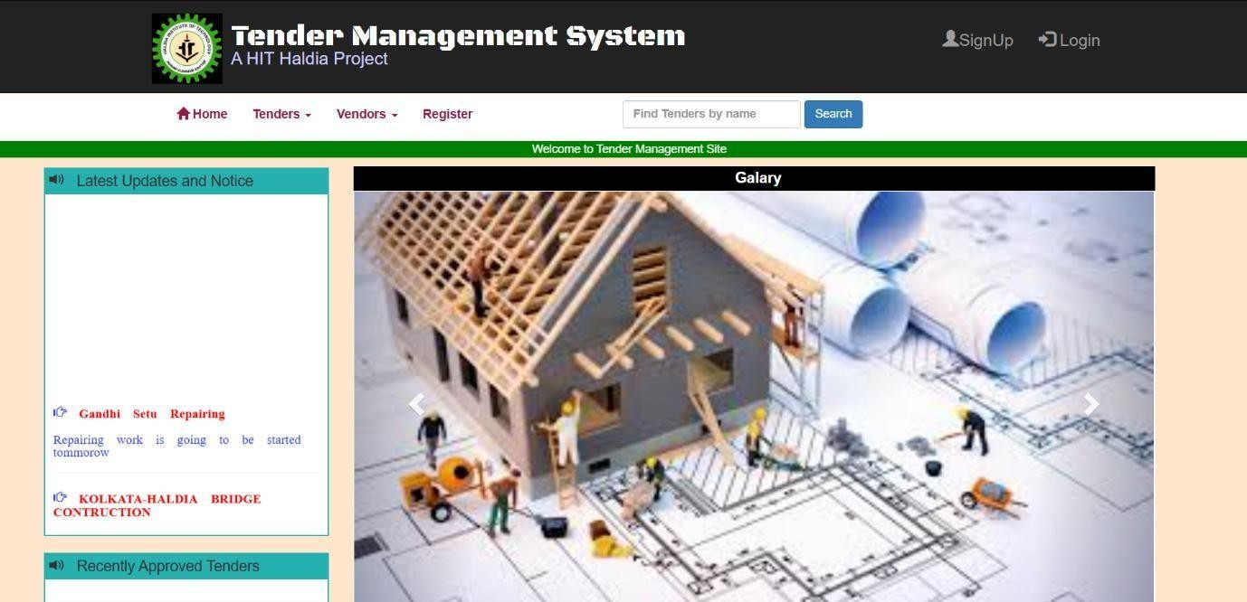

**Login Page**

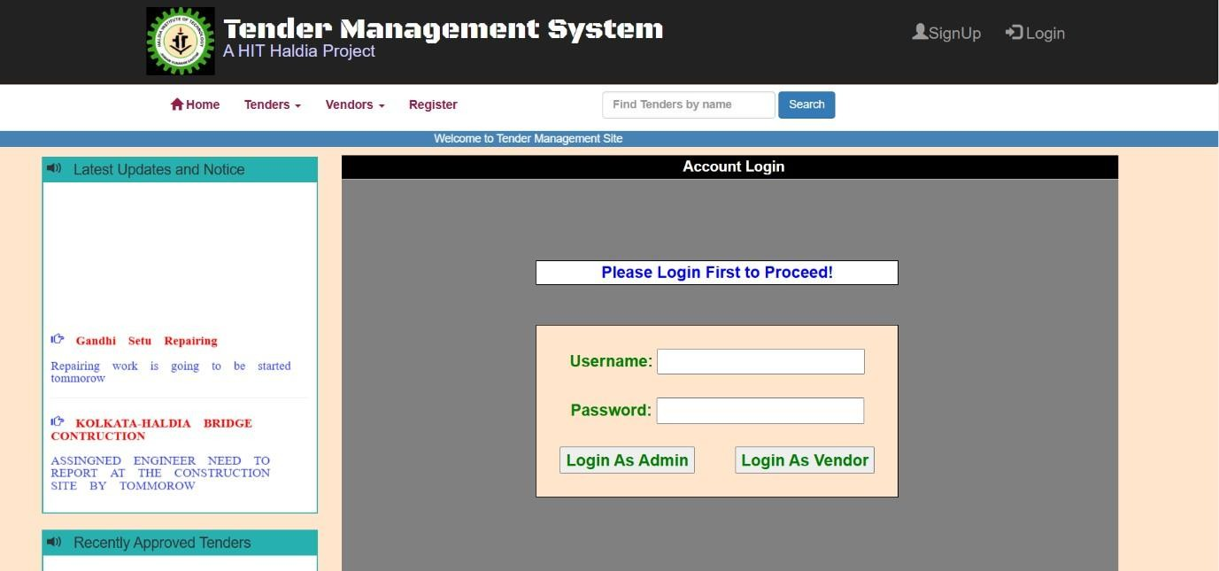

**Vendor Details**

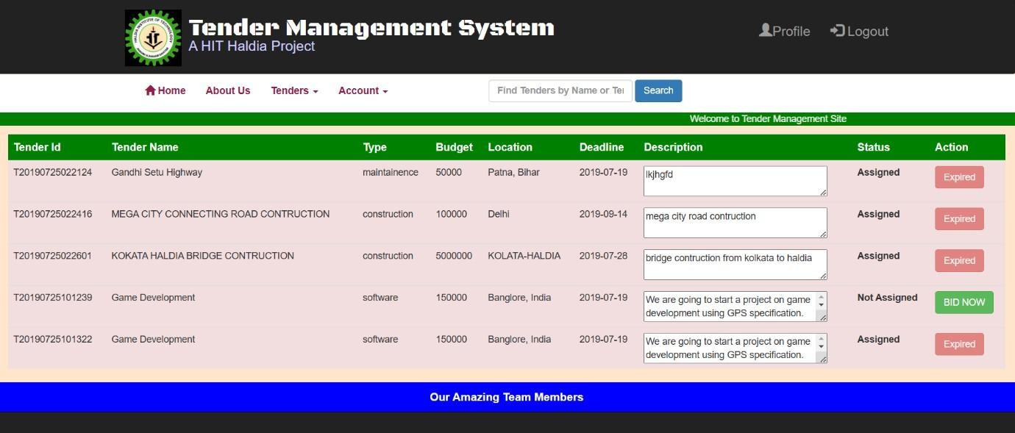

**Vendor History**

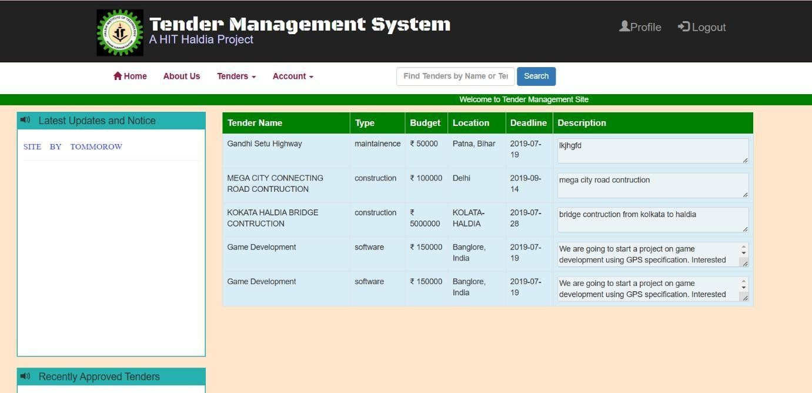

# RESULTS

## User Features:

Registration & Login: Successfully implemented with email confirmation upon registration, ensuring secure access for tender participants.

Tender Browsing: Users could easily view, search, and filter available tenders, allowing efficient navigation and selection.

Bid Submission: Bid submission functionality worked smoothly, with real-time validation of bid requirements and notifications for successful submissions.

Bid Tracking: Users could track their submitted bids and receive status updates via email, improving user engagement and transparency.

Notifications & Reminders: Automated notifications were sent for tender openings, submission deadlines, and bid status changes, helping users stay informed.

## Admin Functionality:

Tender Management: Admins could effectively create, update, or remove tenders, including setting tender details, requirements, and submission deadlines.

Bid Evaluation & Management: Admins could review submitted bids, manage evaluation criteria, and update the status of tenders (e.g., under review, awarded, closed).

User Management: Admins could monitor user registrations, authorize participant accounts, and address user queries efficiently.

## Email Notifications:

Successfully sent automated emails for registration, tender openings, bid submission confirmations, bid status updates, and tender award notifications.

## Performance & Security:

The platform was responsive and performed well under standard testing conditions, though it would require integration with a secure document handling system and enhanced security features for sensitive data in a live environment.

Overall, the project met its goals, delivering a functional and user-friendly tender management platform with effective admin tools and robust

# DISCUSSION

## User Experience:

Strengths: The user interface was intuitive and easy to navigate. Features like tender browsing, filtering, and bid tracking made the tender process straightforward and accessible for users.

Areas for Improvement: The bid submission process, though functional, could be enhanced with additional validation checks and a live document verification system. Incorporating features like user ratings or feedback for completed tenders could add value and transparency.

## Email Integration:

Strengths: The email notification system was effective, ensuring users stayed informed on key tender updates, submission deadlines, and bid status.

Areas for Improvement: Exploring a more robust email service could help manage larger volumes and improve delivery speeds, especially important for time-sensitive notifications.

## Admin Efficiency:

Strengths: The admin panel was well-designed for tender and bid management, enabling efficient organization and monitoring of submissions.

Areas for Improvement: Future enhancements could include features like automated bid evaluation support, tender analytics, and reminders for tender deadlines or bidder follow-ups.

## Security Concerns:

Discussion: Given that tender management involves sensitive information, implementing secure document handling, encryption for bid data, and two-factor authentication (2FA) for user accounts would be essential for production use. Integration of secure digital signatures for bid submissions could further enhance data integrity.

## Performance:

Observation: The platform’s performance was satisfactory, managing concurrent user access effectively. However, stress testing should be performed to verify scalability and response times under high submission volumes and peak usage.

Overall, the tender management system provided a smooth and user-friendly experience while addressing core functionality needs. Enhancements in security, performance.

# CONCLUSION

The development of this tender management system has successfully demonstrated the essential functionalities required for a streamlined and effective tendering process. The project provides a solid foundation by implementing features that cater to both users and administrators, ensuring efficient operation and management of tenders.

From a user perspective, the system offers a straightforward and engaging experience. The registration and login system functions seamlessly, allowing new users to join securely with confirmation via automated email notifications. The bid submission and tracking features further enhance user satisfaction, providing participants with real-time updates and transparency throughout the bidding process—key factors for building trust and encouraging participation.

From an administrative standpoint, the platform provides a comprehensive interface for managing tenders and bids. The admin dashboard simplifies tasks like creating new tenders, reviewing bids, and managing submission deadlines, allowing administrators to operate the platform efficiently and maintain organized records.

The email integration feature significantly enhances the overall user experience. By automating critical notifications, the system minimizes manual tasks and keeps users informed about tender openings, submission deadlines, and bid status updates. This functionality also strengthens user engagement and retention, as it ensures timely communication throughout the tendering process.

In summary, this tender management system meets its objectives by providing a user- friendly, functional, and efficient solution for managing tenders and bids. With further enhancements in security, analytics, and performance, the platform can become a comprehensive solution for a wide range of tendering needs.

# REFERENCES

## Web Development Resources:

W3Schools: Useful for learning and implementing HTML, CSS, and JavaScript fundamentals used in the front-end development of tender management systems. Available at: [https://www.w3schools.com](https://www.w3schools.com/)

## Java and Backend Development:

Oracle Java Documentation: Comprehensive resource for understanding Java programming and Java Standard Edition (JDK 8+), often used in backend development for handling tender submissions and user management. Available at: <https://docs.oracle.com/javase>

## Database Management:

MySQL Documentation: Detailed explanations and best practices for creating and managing relational databases, essential for storing tender data and user information securely. Available at: <https://dev.mysql.com/doc>

## Project Management and Development Tools:

GitHub: For version control and project collaboration, allowing teams to track changes and manage code effectively. Documentation available at: [https://docs.github.com](https://docs.github.com/)

## RESEARCH PAPERS:

Database Management Systems for Tender Platforms: A Survey: Provides insights into the structure and management of databases for platforms handling tenders.

A Survey on Tender Management Systems: Design, Issues, and Challenges: Discusses the architectural considerations and key challenges of developing tender management systems. Available on Google Scholar.

### GITHUB LINK:

<https://github.com/JananiV24/Tender_Management_System.git>

<https://github.com/Maiyesha/Tender-Management-System-.git>